Let’s separate the CPU operation modes to this document.
🧠 CPU Modes Explained:
Part 1 – Real Mode (The Wild West of Computing)

⚙️ What Even Is a CPU Mode?
Before we get deep, here’s the vibe:
A CPU “mode” is like the operating style of the processor.
It defines what the CPU is allowed to do:
- How much memory it can touch.
- Whether it has access control/security.
- What kind of instructions and registers it can use.
It’s like your CPU switching between “beginner,” “intermediate,” and “pro” modes depending on what it’s trying to run.

🧱 Real Mode: The 16-Bit Legacy Arena
🕰️ This is the original mode of the x86 CPU family. Born with the 8086 processor (1978), and every modern x86 CPU still starts in Real Mode when powered on — even your Core i9 or Ryzen 9.
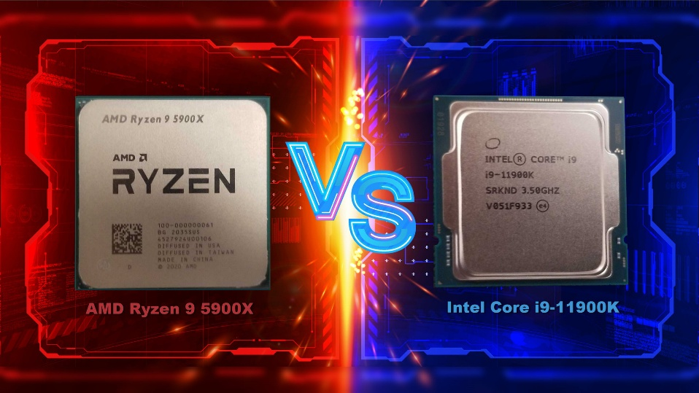

🔍 Key Traits of Real Mode:
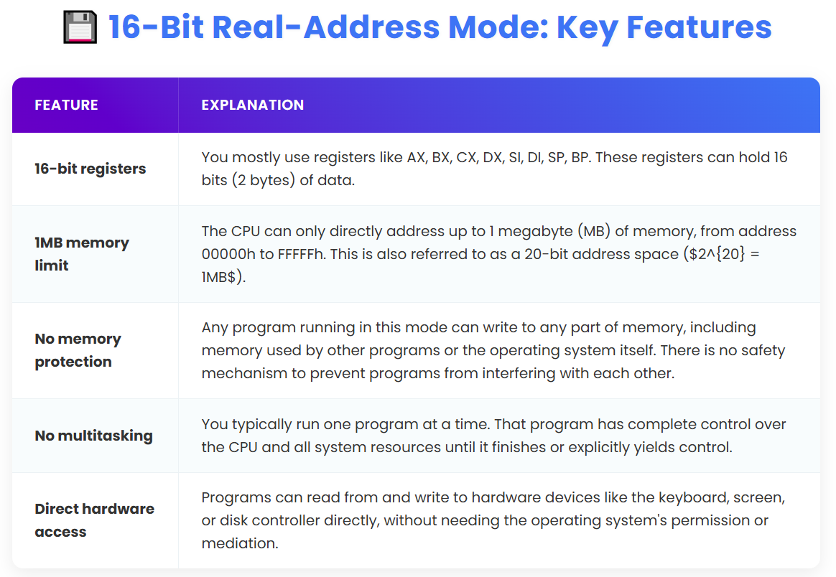
🧪 Addressing Style
Real Mode uses Segment:Offset addressing. It breaks up memory access like this:
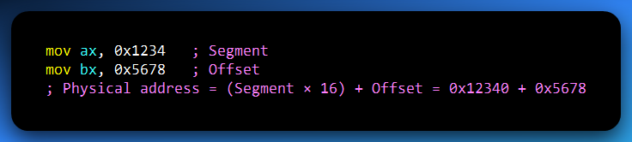
🧠 Basically: Segment × 16 (or left-shift 4 bits) + Offset.
That’s how Real Mode squeezes 20-bit memory access out of 16-bit registers.
I know you didn’t get anything, lets revisit this madness about 16-bit real mode.

🧠 Addressing Style: Segment:Offset in Real Mode (The Old-School Memory Map)
You've seen that 16-bit real mode only uses 16-bit registers (like AX, BX).
But wait, how does it access 1MB of memory (which needs 20 bits for its address)?
This is where the Segment:Offset magic comes in.
Think of it like this:
Imagine you're trying to find a specific house in a very old, sprawling city where the streets aren't perfectly numbered, and your GPS (CPU) is a bit limited.
Your GPS (CPU) can only give you 16-bit numbers. That's like your GPS only being able to tell you numbers up to 65,535. That's not enough to cover a whole city with a million houses!
So, they came up with a two-part address system: Segment:Offset.

